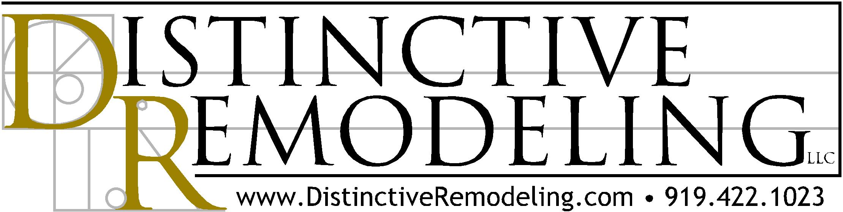

Defining Value
In the current economy, it has become fashionable to define "value" as simply the lowest price. For many, lowest price means best value. It's a tact that has become commonplace in residential remodeling. But doing so discounts the value of providing a high level of construction quality, as well as a remodeling contractor's service before, during, and after a remodeling project is finished. This may not be in a family's best interest.

Remodeling a home is a significant financial investment. Why, then, would an owner trust that investment -- both financially and in his and her enjoyment of it -- to the lowest price and a limited definition of value?

As a professional remodeling firm, we operate with a broader definition of value. We believe value includes a positive experience for the owner and a sense of confidence and pride about the project's quality. Value should also consist of a high level of personal service and a commitment to maintaining a relationship built on trust well after the project's completion date.

Some remodelers play the low-bid game. They narrowly define value as a stripped-down set of specifications and a project on the cheap to achieve a cut-rate price. The goal: make a sale and move on. They typically don't have the staff or systems in place to respond to issues once the remodel is complete.

Here's how we define and deliver a higher level of value:

Communication: As professional remodelers, we listen and respond to our clients' ambitions and dreams for their project. While working within budget, we help define and discover specific wants and needs. We educate them about the complexities of the remodeling process, set realistic expectations and keep them informed about what happens -- and why -- as their project takes shape. Our intent is to be prompt and respectful when we meet. We follow through on promises made and keep our clients informed about a job's progress.

An Efficient Job Site: Our crews and job site managers follow an agreed-upon schedule and detailed list of specifications that we develop with each client. Materials for a project are ordered and delivered as needed and on time. We manage and coordinate our trade partners and materials suppliers toward the common goal of meeting our company's standards and our clients' expectations.

Follow-Through: When a project is complete, we don't disappear. We know that it is critical to our clients' ultimate satisfaction that we continue effective communication while providing thorough and prompt service. When issues crop up -- and they always do -- we have policies and procedures in place to respond in a timely fashion. We work the problem; we don't pass the buck. We belong to this community. This is where we've chosen to raise our family and we intend to be here for years to come.

We believe our definition of value instills confidence and helps ensure client satisfaction. We respect that our clients' entrust us to deliver a project that initially only exists on paper and is created before their eyes. It's a responsibility we take seriously, and it's the cornerstone of what we call value.

